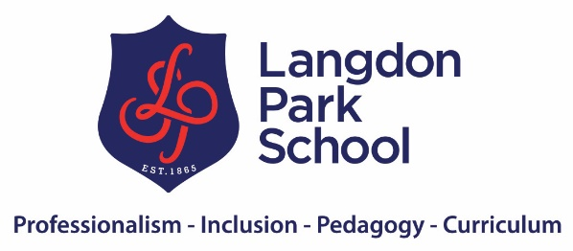

Parent and student checklist for home
Before school – students should pack their bags and get uniform ready the night before.
Equipment | Yes | No
Planner – signed weekly by parent
Pencil case (includes 2x black ink pens, two sharp pencils, rubber, ruler and protractor, highlighter pen) Notes scissors are not allowed in school.
Calculator needed for maths and science lessons
Bottle of water
Fruit health snack (optional)
Reading book

Equipment will be checked by form tutor and teachers each lesson. Students who do not have correct equipment will receive negative behaviour points. Students must be in the habit of being fully equipped for school. When they sit exams and assessments we will not lend equipment.
Uniform (see uniform policy) | Yes | No
Tie, blazer, grey trousers or skirt, black shoes, blue headscarf
No jewellery
Earrings must only be small plain studs
No make-up or lip gloss
No nail polish or nail extensions

Uniform will be checked at the school gate and in tutor time. Students who are not in correct uniform will be sent home to change or placed in reset. We have uniform stock if needed including shoes. We will not accept notes for wearing trainers unless a GP note is provided for a medical reason.

Punctuality / travelling to school | Yes | No
Leave home to be at school before 8.35am
Must leave early if there are known transport issues and road works
Ideally students should walk to school for good exercise
Students are encouraged to travel to school with their friends

If your child is late to school, they will be placed in lunchtime detention. If they arrive after 9.00am they will receive a 60-minute detention. You will be notified via text if your child arrives late to school. The LA will send Fixed Penalty Notices for persistent lateness. There are no excuses for lateness. The school library is open from 7.30am and there are breakfast clubs too.

After school
Reading | Yes | No
Your child should read for pleasure for at least 30 minutes each day
When possible listen to your child reading for a short while and discuss what they are reading
Check on the school website for recommended reading
Try to encourage your child to watch documentaries and relevant films to support learning with subtitles on. This will help with reading.

Reading regularly is the basis for success at GCSE and A-level, it is as simple as that and research supports this. The students with a combination of attendance of 95% plus and regularly reading achieve the best academic outcomes. So, the best thing you can do at home is encouraging your child to read each day.

Home Learning | Yes | No
Your child should be making a record of home learning activities in their planner. Please check this.
Have a timetable organised for after school homework and activities.
All lessons are on Google Classroom, so students can go back over and revisit prior learning.
Your child always has home work as there are books to be read and revision to be completed.
Your child will have spellings and key words to learn each term.
Encourage your child to watch relevant documentaries and listen to podcasts and so try to reduce their time on social media.
Discuss learning with your child and get them to teach you about what they have been learning. This will help them to understand it more.

At Langdon Park we believe that intelligence is not fixed, no one child is ‘smarter’ than another. To make academic progress your child must work at it. This doesn’t mean them getting stressed and worried, it is about daily application and following a routine. There should be plenty of time outside of this for other activities etc. try to reduce the access to phones and play stations etc. use this time as an incentive after school work is done.

